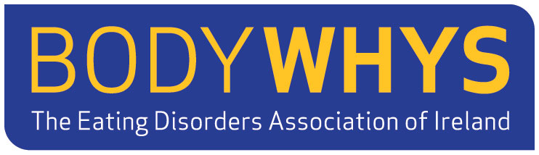

Job Specification

Organisation: Bodywhys: The Eating Disorders Association of Ireland
Address: P.O. Box 105, Blackrock, Co. Dublin
Position: Office Manager
Reporting to: Chief Executive Officer
Closing Date: Friday, September 23rd , 2022

Bodywhys – the Eating Disorders Association of Ireland is currently recruiting for the full-time post of Office Manager to join a small team at its Central Office. The ideal candidate should be reliable, competent, and self-motivated.

Responsibilities:
- Co-ordinate administrative duties including, but not limited to, the monitoring, controlling, and ordering of all office supplies, maintaining all office equipment and IT systems; and booking of meetings, training/conferences, external talks and events, accommodation, and travel.
- Recording minutes of Team Meetings and Annual General Meetings.
- Processing, receipting, and lodging of monies.
- Stock-taking and management of literature and documentation at company off-site storage location on monthly/as needed basis.
- Provide support during the recruitment, vetting, and training of personnel (volunteers and staff) as required.

- Manage phone calls and correspondence (e-mail, postage, letters, etc.).
- Manage and maintain records and databases (including data logging using the CRM platform, Salesforce).
- Review and ensure up-to-date and accurate information on Bodywhys Directory of Services.
- Support coordination of education/training course bookings and supporting documentation.
- Coordinate the production of company documentation; liaise with design company regarding literature including leaflets, brochures, social media posters, and annual reports.
- Provide cover and support to Bodywhys supports services where needed, primarily the helpline and email support services.
- Other duties as indicated by the Chief Executive Officer.

Requirements:
- Proven experience as an Office Manager or Senior Office Administrator.
- Excellent proficiency in MS Office, Google Workspace, and office management software (CRM platform Salesforce).
- Effective communication and interpersonal skills.
- Strong organisational and time management skills.
- Excellent attention to detail.
- Knowledge of eating disorders and treatment services in Ireland.

Based in:
The position will be based in the Bodywhys Central Office which is currently located in St. John of God Hospital, Stillorgan, Co. Dublin.

Hours of work:
The position will be 5 days per week with office hours from 9 a.m. – 5 p.m. Where out of office hours occur, a time off in-lieu system operates.

Length of Contract:
Permanent position subject to a 6-month probationary period and continued funding being made available to the organisation by the Health Services Executive (HSE) annually.

Salary: circa €30,000

