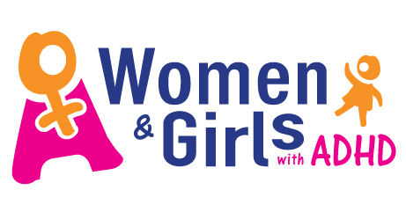
ADHD Seminar October16th.2017
Venue: Silver Springs Hotel Athlone
You are cordially Invited to attend.
Keynote Speaker: Dr. Laura Muggli
“ Links with ADHD and Eating Disorders”

Dr. Padraig MacNeela: Dr. Ryan O’Neill
Dr. Michael Keane: Ms Heather Blackmore
Information and bookings Email info@incadds.ie Ph.091755090
Time 9am to 4Pm: €50 including lunch.

